An Efficient Reverse Geocoding Method based on Global Subdivision Model

Mengyu Ma, Zhinong Zhong*, Ning Guo, Ning Jing, Wei Xiong
College of Electronic Science and Engineering,
National University of Defense Technology, Changsha, China
*Corresponding author, e-mail: nong_nudt@hotmail.com

Abstract—As a critical component of Location-Based Service(LBS), reverse geocoding is the process of converting a coordinate obtained by GPS to a readable street address. With the widespread use of location-aware mobile electronic devices and the extensive application of LBS, the capability of reverse geocoding is in high demand. Meanwhile, with the constantly expanding of spatial data size, the computing quantity of reverse geocoding continues to increase. Based on Global Subdivision Model(GSM), this paper presents an efficient reverse geocoding method named Geohash-based reverse geocoding(GBRG). In GBRG, spatial objects are encoded to Geohash codes which can be used to identify the location of the spatial objects. A key point in this step is encoding spatial line objects and region objects with an adaptive Geohash method. Then the spatial objects near the given coordinate are retrieved by comparing the Geohash codes. In order to make sure that the nearest spatial objects are in the scope of the results retrieved, we use the eight neighborhood for retrieval. PostGIS provides a lot of functions for geometric calculation and we use these functions to determine the spatial relations between the given coordinate and the spatial objects. We carry out some experiments using the data of Beijing, China. The results show that GBRG is of high efficiency with some loss in accuracy which can be ignored without obvious influences.
Keywords—global subdivision model, Geohash, reverse geocoding, location based service, geocomputation

Introduction
In recent years, with the rapid development of location-aware mobile electronic devices, Location-Based Service(LBS) has become more and more important in almost all social and business domains. LBS is an information service mainly making use of geographic position of mobile phone to provide accurate services for consumers [1]. Reverse geocoding is a critical component of LBS to convert a coordinate obtained by GPS to a readable street address which is easier to understand by users [2].
Supported in part through a Chinese HTRDP(863) grant (2015AA123901)
These days, reverse geocoding has become very popular [3-7]. There are a lot of public reverse geocoding services, and most of these services are available free of charge. These services provide friendly application programming interfaces(API), and it is easy for programmers to use these APIs. GeoNames reverse geocoding web service is a typical example of these services which provides tools to find nearby place names, Wikipedia articles, streets, neighborhoods, country, country subdivisions, and other location data from a coordinate [8]. Additionally, both Google and ArcGIS offer reverse geocoding services for geographical scope of the entire world [9-10]. However, it is because different countries tend to adopt different address representation methods that the global scale reverse geocoding services are not applicable in some countries. In China, Baidu and Amap offer reverse geocoding services which use Chinese address representation method and can provide better user experience for Chinese [11-12]. Some researches evaluated the performance of public reverse geocoding services [13]. In the aspect of implementation principle, current reverse geocoding methods are generally based on building variants of R-tree or R-tree index structure [14-15] to organize spatial data and making complex spatial query based on the indexes. [16] So the efficiency of current reverse geocoding methods is greatly determined by the performance of the Indexes.
With the widespread use of location-aware mobile electronic devices and the extensive application of LBS, the capability of reverse geocoding is in high demand. Meanwhile, with the constantly expanding of spatial data size [17], the computing quantity of reverse geocoding continues to increase. So in order to keep up with the high demand, it does make sense to find out a new reverse geocoding method which is more efficient.
Based on Global Subdivision Model(GSM), this paper presents an efficient reverse geocoding method named Geohash-based reverse geocoding(GBRG). GSM divides the whole earth surface into multi-level and multi-scale cells and constructs an index system of global spatial data. There could be various implementation of GSM based on different subdivision method: regular polyhedron subdivision (e.g. SQT and QTM) [18-19], adaptive grids subdivision [20]and equal-angle grids subdivision (e.g. SIMD) [21]. Geohash [22] is a geographical encoding method based on the equal-angle grids subdivision GSM. Geohash has the advantages of low computation quantity and adjustable precision. And we applied Geohash as the theory base of GBRG. In the traditional reverse geocoding method, the spatial data is organized by spatial indexes, and data is retrieved based on the indexes. In GBRG, we encode all the spatial data with Geohash and retrieve data by comparing Geohash codes. The multidimensional spatial data is mapped to one dimension and the retrieval is simplified to one dimension, which lead to a higher performance reverse geocoding service.
This paper is organized as follows. In Section 2, the data organization using Geohash is introduced, and this section is the core of the paper. The concrete implementation process of GBRG appears in Section 3. The experiments and results are discussed in Section 4 with conclusions of the paper being reserved for Section 5.

DATA ORGANIZATION USING GEOHASH
In this section, we explain how to organize data in GBRG. Data organization is the foundation of reverse geocoding and this section is the core of the paper. The section is divided into three parts, main content as followed: The first part describes the characteristics of data; The second part explains how to encode data with Geohash; And the last part explains how to store the data in database.

Characteristics of data
The purpose of reverse geocoding is to convert a point location to a readable address or place name, so reverse geocoding should be based on a database which can be used to translate between different representations of geospatial references. And there should be three types of data objects in the database: point objects, line objects and region objects. Point objects are used to represent points of interest(POI), which include hotels, campsites, fuel stations or any other categories used in modern navigation systems. Point objects have simple structure, which uses two decimal numbers to represent the coordinate of a place. However, the number of point objects is huge because of large number of POI. Line objects are used to represent roads. Region objects are used to represent districts, cities, provinces, countries, etc. Both line objects and region objects share the same feature that different objects may have big differences in size and shape.

Implementation of Geohash
Geohash is a geographical encoding method which represents each longitude-latitude pair with a code. The principle of Geohash is to divide the whole earth surface into grids with lines of latitude and longitude, then each grid is encoded into a code. Actually, the theory of Geohash is mapping multidimensional data to one dimension with the Z-order curve [23]. Geohash encodes every location into a code which uniquely identifies positions on the Earth. The longer the code is, the more accurately the location is encoded. And the accuracy can be as high as required so long as the code is long enough. What' s more, Geohash codes of nearby places often have similar prefixes. The longer the shared prefix is, the closer the two places are. However, it should be pointed out that not all nearby places have Geohash codes with similar prefixes. It is an inevitable consequence of relying on the Z-order curve to order the points.
Then this paper discusses how the point objects, line objects and region objects are encoded with Geohash in details. A key point in this approach is encoding line objects and region objects with an adaptive Geohash method.

Encode point objects
The steps to encode point objects with Geohash are as follows: Firstly, represent the earth's surface with the global longitude-latitude rectangle [-180°,180°] [-90°,90°]. Next, divide the rectangle into two squares ([-180°,0°] [-90°,90°] and [0°,180°] [-90°,90°]) with a latitudinal line. If a point object is to the left of the latitudinal line, encode the point object beginning with a ‘0’, and if not, encode the point object beginning with a ‘1’. Then, divide each of the squares with a longitudinal line. Add a ‘0’ to the Geohash codes of point objects below the longitudinal line and a ‘1’to the Geohash codes of point objects above the longitudinal line. This dividing continues until the required accuracy is achieved. The longer the Geohash code is, the more accurately the location is encoded. The dividing process of Geohash is shown in Fig.1.

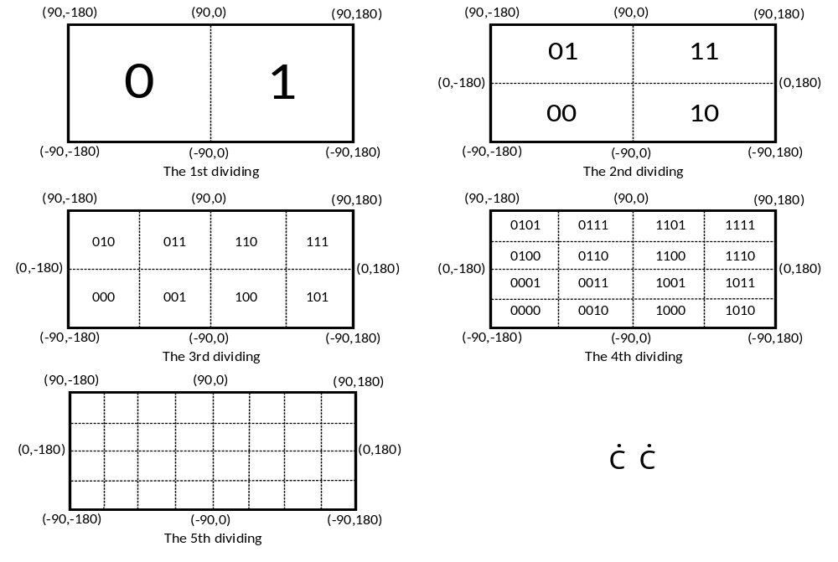
- The dividing process of Geohash

Take Changsha Railway Station for an example. Changsha Railway Station can be represented with a point object of which the coordinate is (28.194, 113.012). The Geohash code of the coordinate can be a binary number of length 40:
1110011001000000001000111110001100001011
In the usual process of Geohash, one more step is needed. In the step, each 5 bits of the binary number is converted to one character and the Geohash code finally comes out as a readable string. However, the Geohash code represented as a string is less flexible, and practice shows that the retrieval based on character is less efficient than the retrieval based on numerical data. So in this paper, we use binary numbers to represent Geohash codes.

Encode line objects and region objects
Different from point objects, line objects and region objects have the attributes of size and shape, and different objects may have big differences in size and shape. So the method to encode point objects is not suitable for line objects and region objects.
An intuitive method to encode line objects and region objects is as follows: (1) Calculate the Minimum Bounding Rectangle (MBR) of the target object; (2) Select the two points at the lower-left corner and the upper-right corner of the MBR as point objects A and B; (3) Calculate the Geohash codes of A and B as codeA and codeB; (4) Calculate the longest same prefix of codeA and codeB, and the prefix is the Geohash code of the target object. The method above is simple and has low computational complexity. In this method, each of the spatial objects is encoded into a Geohash code, and a bigger spatial object often has a shorter Geohash code. However, there is a serious defect in the method. For example, if the target object is a line object from point (-0.001, 40.000) to point (0.001, 40.002) (see Fig.2), then the Geohash code will be a single binary: 1. The Geohash code of the line object is the representation of the grid [0°,180°] [-90°,90°], but the spatial span of the line object is less than 0.01°. It is inappropriate and will severely reduce the retrieval efficiency of spatial objects.
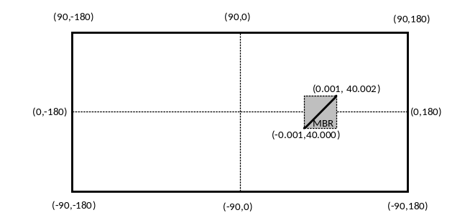
- An example to show the defect of the intuitive method
In this paper, we present an adaptive Geohash method to encode line objects and region objects. In this method, each spatial object is encoded into one to four Geohash codes. The basic ideas of the method are as follows: Firstly, determine the length of the Geohash code according to the MBR of the target object; Secondly, encode the four corner points of the MBR into fixed-length Geohash codes with the length determined in the first step; In the end, select the distinguished types from the Geohash codes of the four corner points as the Geohash codes of the target object. We next provide technical details on this method.

Determine the length of the Geohash code adaptively.
The main objective of this process is to determine the length of the Geohash code according to the size of the target object. And the length should be suitable in case that the Geohash codes can not only contain the target object entirely but also avoid containing a large number of uncorrelated spatial regions. The steps of this process are as follows:
Step 1: Calculate the Minimum Bounding Rectangle (MBR) of the target object and express the MBR as ((ll_lng, ll_lat), (ur_lng, ur_lat)). (ll_ lng, ll_lat) is the coordinate of the lower-left corner point, and (ur_lng, ur_lat) is the coordinate of the upper-right corner point. Then the ranges of the MBR in latitude and longitude can be expressed as:
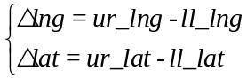 (1)
Step 2: Determine the length of the Geohash code according to the ranges of the MBR. The length of the Geohash code is expressed as L. Each spatial object is encoded into no more than four Geohash codes, so the following formula should be satisfied to make sure the Geohash codes can contain the target object entirely (annotate: ⌈A⌉ rounds the elements of A to the nearest integers greater than or equal to A and ⌊A⌋ rounds the elements of A to the nearest integers less than or equal to A):
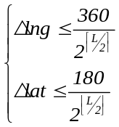 (2)
And in order to encode the target object more accurately, L should be as long as possible. Therefore, L can be determined by the following formula:
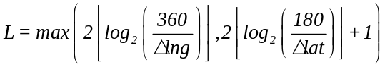 (3)

Encode each spatial object into one to four Geohash codes.
The next process is to encode the target object into Geohash codes of length L. Firstly, calculate the Geohash codes of length L of the points at the corners of the MBR, and the results are code1, code2, code3 and code4 in turn (see Fig.3). Then, compare the four Geohash codes. As shown in Fig.4(a), if code1code2code3code4, then the target object intersects with one grid and can be encoded into only one Geohash code; If code1code4 and code1code2 (code1code2 and code1code4), then the target object can be encoded into two Geohash codes, as shown in Fig.4(b); If code1code2code3code4, then the target object intersects with three or four grids and we need to read the boundary data of the target object to determine the final Geohash codes, as shown in Fig.4(c) and Fig.4(d).
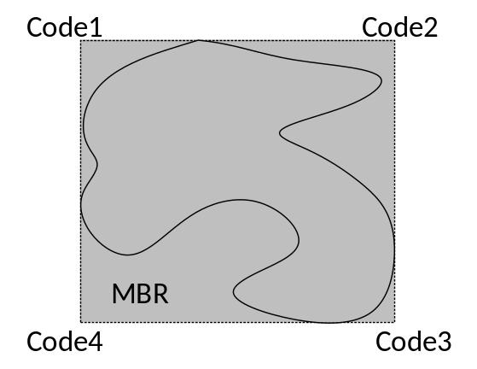
- The Geohash codes of the points at the corners of the MBR
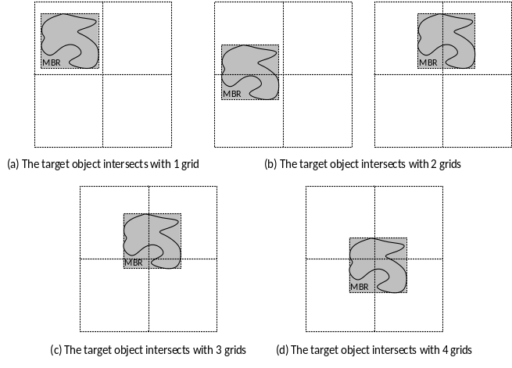
- The position relation between the target object and grids

Establishment of database
After encoding the spatial objects, each point object is represented with one Geohash code and each line object or region object is represented with one to four Geohash codes. We can use Geohash codes instead of the original spatial data to identify the location of the spatial objects. In this part, we cover how to organize the three types of data objects in database. The process includes creating tables and building indexes.
The storage structure of Geohash codes in database is determined at first. The database we used is PostgreSQL which has a good support for spatial data (PostGIS [24]). However, the data type of unsigned integer is not supported by PostgreSQL [25], so we use the 64-bit signed integer to store the Geohash code. The storage structure is shown in Fig.5. The highest bit is a sign bit which is not used. The lowest 6 bits are used to store the length of the Geohash code. The remaining 57 bits are used to sequentially store each bit of the Geohash code, and the highest bit of the Geohash code is stored in the 63rd bit.
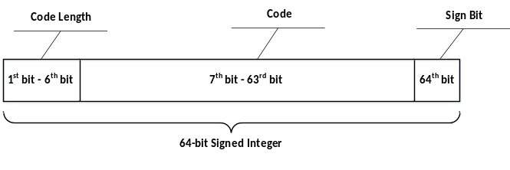
- The storage structure of Geohash codes in database
As shown in Fig.6, we create a table to store point objects, and some important attributes are listed in the Figure. ID is a label which uniquely identifies point objects. NAME is the name of the place which the point object represents. WKB_GEOMETRY is used to store the coordinate of point objects. Each point object has only one Geohash code, so the Geohash code can be stored as an attribute of the point object. In the implementation of reverse geocoding, Geohash codes are used to speed up the retrieval of spatial data. In the process of retrieval, range predicates (,,and ) are used many times, and B+ Tree index has high efficiency in this kind of retrieval, so we build a B+ Tree index on the Geohash codes.
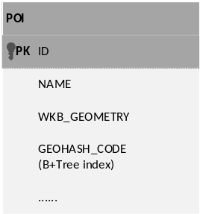
- Table structure of point objects in database
As shown in Fig.7, we create two tables to store line objects. Each line object is encoded into one to four Geohash codes. So if the Geohash codes is stored as an attribute of the line object, it will be difficult to build an index on the Geohash codes. As a result, we create two tables: GEOHASH_LINE and ROAD. ROAD is used to store the attributes of the line objects. GEOHASH_LINE is used to store the correspondences between the Geohash code and the ID of line objects. Then if the Geohash code is determined, we can use the ID to find the line object. And in the process of finding the line object, equality predicate ()is used, so a hash index is built.
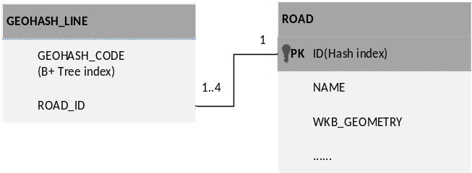
- Table structure of line objects in database
As shown in Fig.8, we create five tables for region objects. Region objects are used to represent country subdivisions. Country subdivisions have multiple levels, and there are affiliations between different levels. In the implementation of reverse geocoding, when the spatial relationship between a point location and the lowest level of country subdivisions is determined, the spatial relations between the point location and all levels are also determined. So we create four tables (DISTRICT, CITY, PROVINCE, COUNTRY) to store country subdivisions and only the DISTRICT level is encoded with Geohash.
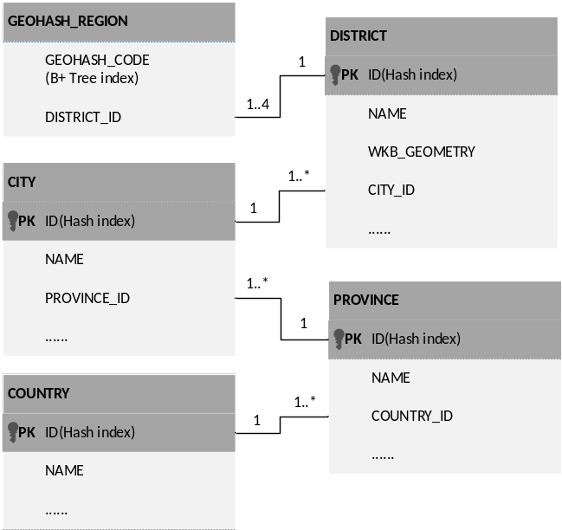
- Table structure of region objects in database

GEOHASH-BASED REVERSE GEOCODING
In the previous section, the data organization based on Geohash is explained. Next, in this section, we introduce concrete implementation process of GBRG. This section is explained in three parts. The first two parts introduce some technical details which is the core process of GBRG. The third part shows the flow of GBRG.

The eight neighborhood of a grid
In the process of Geohash, the whole earth surface is divided into grids with lines of latitude and longitude. The eight neighborhood of a grid is composed of the eight adjacent grids of the grid. As shown in Fig.9, the eight neighborhood of G is the hatched portion.
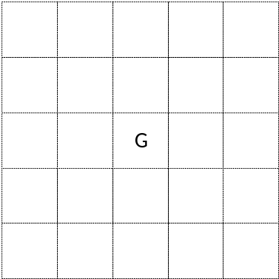
- The eight Neighborhood of G
Actually, the essential process of reverse geocoding is to find the nearest spatial objects to a given coordinate. In GBRG, spatial objects are encoded with Geohash, and spatial objects near the given coordinate can be efficiently retrieved by comparing the Geohash codes. In order to make sure that the nearest spatial objects are in the scope of the results retrieved, the spatial objects intersecting with the nearby grids of the given coordinate should also be retrieved. So in our approach, we use the eight neighborhood for retrieval.
The way to find the eight neighborhood is simple, and the process is as follows: (1) Determine the size of grids used according to the retrieval range and express the size as (lng_g, lat_g); (2) Express the given coordinate as (lng_p, lat_p), and eight points in the eight neighborhood can be determined (see Fig.10); (3) Encode the eight points with Geohash respectively and the results are the Geohash codes of the grids in the eight neighborhood.
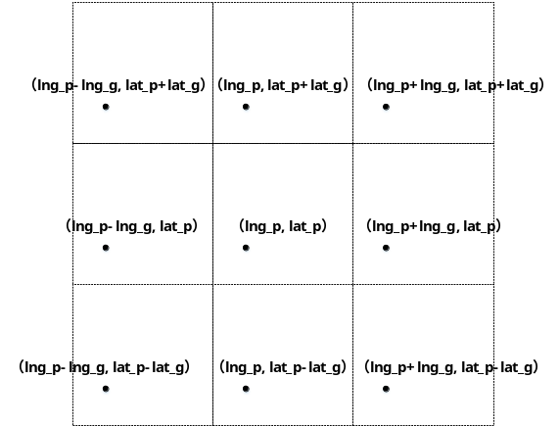
- The eight points in the eight neighborhood

The objects intersected with a grid
As mentioned before, retrieving spatial objects near the given coordinate is a necessary process of GBRG. Actually, the process is to find the spatial objects intersected with the grids near the given coordinate. The implementation of the process is through comparing the Geohash codes of the grids and the spatial objects. Respectively express the length of Geohash codes of the grids as L_G and the spatial objects as L_S. According to the different size relation of L_G and L_S, the implementation can be divided into two cases:
Case 1: L_G L_S
As shown in Fig.11, the hatched portion is the representation of the grid used for retrieval. A, B, C, D, E are five spatial objects with longer Geohash codes. The objects A, B, C intersect with the grid while D, E do not. Our purpose is to filter out D, E and retrieve A, B, C. In this case, the spatial object intersected with the grid is characterized as follows: At least one Geohash code of the spatial object has a prefix which is the same as the Geohash code of the grid. We can firstly retrieve the Geohash codes with a prefix the same as the Geohash code of the grid, and then use the Geohash codes to find the spatial objects. In Fig.11, the objects A, B, C is in the grid and have Geohash codes with a prefix the same as the Geohash code of the grid, while the objects D, E is not in the grid and do not have the characteristic. At last, the objects A, B, C can be retrieved and our purpose is achieved.
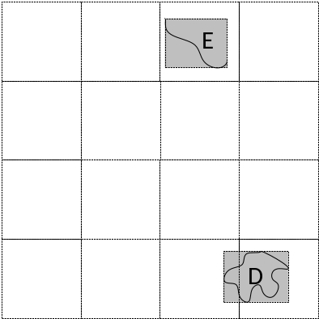
- The Geohash code of the grid no longer than the Geohash codes of the spatial objects
Case 2: L_G > L_S
As shown in Fig.12, the hatched portion is the representation of the grid used for retrieval. A, B, C, D are four spatial objects with shorter Geohash codes. The objects A, B intersect with the grid while C, D do not. Our purpose is to filter out C, D and retrieve A, B. In this case, the characteristic of the spatial object intersected with the grid is as follows: The Geohash code of the grid has a prefix which is the same as a certain one Geohash code of the spatial object. In order to find this kind of spatial objects, we use all the prefixes of the Geohash code of the grid for retrieval. Then retrieve the Geohash codes which are the same as one of the prefixes and use the Geohash codes to find the spatial objects. In Fig.12, each of the objects A, B has a Geohash code the same as a prefix of the Geohash code of the grid, while the objects C, D do not have. In this method, the objects A, B can be retrieved at last.
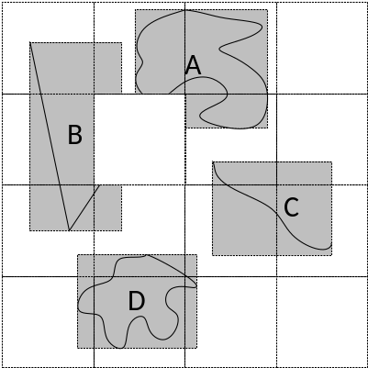
- The Geohash code of the grid longer than the Geohash codes of the spatial objects

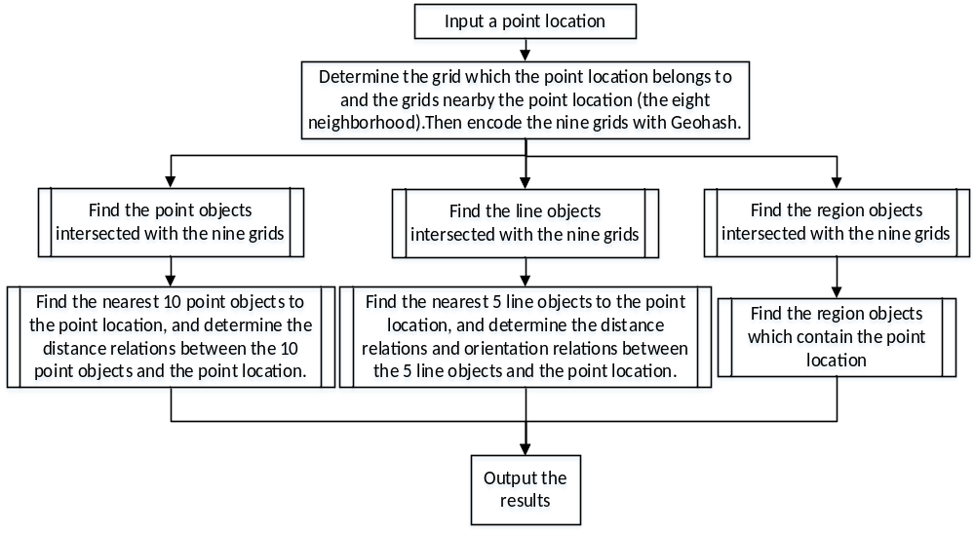
- The flow of Geohash-based reverse geocoding

The flow of reverse geocoding
Reverse geocoding is the process of converting a coordinate obtained by GPS to a readable street address. The essence of reverse geocoding is to find the nearby spatial objects of the point location and determine the spatial relations with these objects. PostGIS provides a lot of functions for geometric calculation and we use these functions to determine the spatial relations. The spatial relations include spatial topology relations, spatial orientation relations and spatial distance relations. The spatial relations are then used to describe the point location. In the first two parts of the section, the ways to find the eight neighborhood of a grid and retrieve the spatial objects intersected with a grid are introduced in detail. The two parts are the core process of GBRG. The flow of GBRG is described in Fig.13.

EXPERIMENTS AND RESULTS
In order to prove the superiority of GBRG, we compare GBRG with a traditional reverse geocoding method by experiments. Different from GBRG, the spatial objects are organized by R-tree indexes in the traditional method. The main difference between the two methods is the way of finding the spatial objects near the given point location. In GBRG, we retrieve the nearby objects by finding the spatial objects intersected with the nine grids (the grid which the point location belongs to and the grids nearby the point location). In the traditional method, we retrieve the nearby objects by finding the spatial objects intersected with a circle which centered at the given point location. Then the nearby objects are used to find the nearest objects. What needs to be explained is that the nearest objects may not be in the scope of the results retrieved by the nine grids. And this may reduce the accuracy of GBRG. In this paper, two experiments are conducted to analysis the efficiency and accuracy of GBRG.

Experimental conditions
- Experimental server configuration
Item | Description
CPU | 16core*12, Intel(R) Xeon(R)E5-2640 v2@2.00GHz
Memory | 64GB*12, DDR3
Network | InfiniBand
Operating system | CentOS 6.3  X86_64
- Experimental client configuration
Item | Description
CPU | 4core, Intel(R) Core(TM)i5-2300@2.80GHz
Memory | 4GB
Operating system | Windows7  X86_64
- Experimental Datasets
Dataset name | Data type | Object number | Source
Beijing_POI | Point object | 385792 | DatatangError: Reference source not found
Beijing_ROAD | Line object | 226237 | DatatangError: Reference source not found
China_DISTRICT | Region object | 3133 | Baidu Maps APIError: Reference source not found
China_SUBDIVISION | -- | -- | National Bureau of Statistics of ChinaError: Reference source not found
The datasets we used is shown in Table 3. Beijing_POI stores the POI information of Beijing, China. And there are about 385 thousand point objects in the dataset. Beijing_ROAD stores about 226 thousand road objects of Beijing. China_DISTRICT is the boundary data of the counties in China. We get the boundary data through Baidu Maps API and the data is shared in Google Drive [30]. China_SUBDIVISION stores country subdivisions of China.

Experimental implementation
In the experiments, the radius of the circle in the traditional method is 1km and the Geohash codes of the nine grids are with a length of 30 (the size of the grids is about 0.9342km0.6097km).
Experiment 1: Efficiency Test
We select six point locations as input to test the efficiency of GBRG. The density of the spatial objects is different near the six point locations. The details of the six points are shown in Table 4. The experimental results are shown in Fig.14.
- The details of the six input point locations
Input point | The Coordinate of the point | Number of point objects near the point (in range of 1km) | Number of line objects near the point (in range of 1km)
P1 | (116.0709,39.6498) | 103 | 138
P2 | (116.2840,39.7808) | 442 | 178
P3 | (116.8413,40.3743) | 1460 | 439
P4 | (116.3978,39.8959) | 2071 | 501
P5 | (116.3955,39.9395) | 2754 | 391
P6 | (116.3908,39.8895) | 3037 | 631

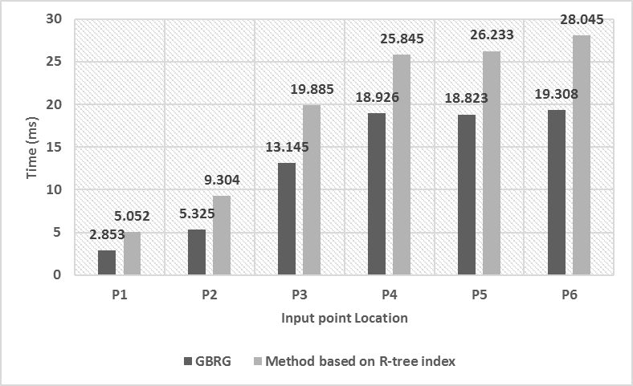
- The conversion time of the six point locations
As shown in Fig.14, when the input point is any one of the six point locations, GBRG always consumes less time. The results show that GBRG is more efficient. And the conversion time in GBRG is reduced to about two-thirds of the conversion time in the traditional method. It is because that in GBRG the multidimensional spatial data is mapped to one dimension and this makes the retrieval simpler.
The implementation of reverse geocoding can be divided into three parts, namely the process of point objects, line objects and region objects. In order to have a better analysis of GBRG, we select the point location P6 as input and analyze the performance of the 3 processes separately. The experimental results are shown in Fig.15.
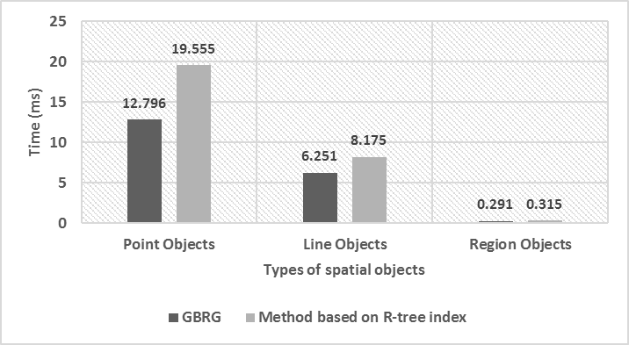
- The time of processing the three types of spatial objects with P6 as input
As shown in the figure above, in the process of point objects, line objects and region objects, GBRG is always more efficient. However, in the process of region objects, the advantage of GBRG is not obvious. It is because that we fail to obtain the region objects with more details. The region data we get is only accurate up to the district level.
Experiment 2: Accuracy Test
Next, we conduct an experiment to test the accuracy of GBRG. It is believed that the results of the traditional method are completely correct. In the experiment, we randomly select 1000 point locations in Beijing as input and determine the accuracy of GBRG by comparing the nearest spatial objects retrieved in GBRG with the objects retrieved in the traditional method. The experimental results are shown in Table 5.
- The experimental results of accuracy test with 1000 point locations as input
Description | Number | Percentage
Completely correct | 993 | 99.3%
Only 1 spatial object is wrong | 5 | 0.5%
More than 1 spatial objects are wrong | 2 | 0.2%

The experimental results show that accuracy loss exists in GBRG. However, the accuracy loss is not serious and can be ignored. 99.3% of the input points returns the results which are completely correct. The input points which return the wrong results are in the areas where the density of the spatial objects is low. These areas are always in the suburbs where the demand for reverse geocoding is low. So the accuracy of GBRG can meet the needs of users.

CONCLUSION
In this paper, we introduce an efficient reverse geocoding method based on GBRG. In GBRG, the multidimensional spatial data is mapped to one dimension with Geohash and the retrieval is simplified. Experiments show that GBRG has a high efficiency while the accuracy loss can be ignored. However, there is still a limitation that GBRG does not apply well to the areas in the high latitudes. As mentioned in this paper, the grids of the same level share the same latitude and longitude span. But the size of the grids changes along with latitude. In the high latitudes, the number of kilometers corresponding to the same longitude span is very small and this will seriously affect the accuracy of GBRG. Further research will be done to overcome the shortcoming.

References
- I. A. Junglas, R. T. Watson, “Location-based services,” Commun. ACM, vol. 51(3), pp. 65-69, 2008. doi: 10.1145/1325555.1325568
- L. M. Surhone, M. T. Timpledon, S. F. Marseken, Reverse Geocoding. Betascript Publishing, 2010.
- J. Krumm, “Inference attacks on location tracks,” IEEE Pervasive Computing, vol. 4480, pp. 127-143, 2007. doi: 10.1007/978-3-540-72037-9_8
- X. Cao, G. Cong, C. S. Jensen, “Mining significant semantic locations from GPS data,” Proceedings of the VLDB Endowment, vol. 3(1), pp. 1009-1020, 2010. doi: 10.14778/1920841.1920968
- L. Stenneth, O. Wolfson, P. S. Yu, B. Xu, “Transportation mode detection using mobile phones and GIS information,” in Proc. 19th ACM SIGSPATIAL International Symposium on Advances in Geographic Information Systems, Chicago, USA, 2011, pp. 54-63. doi: 10.1145/2093973.2093982
- J. Rekimoto, T. Miyaki, T. Ishizawa, “LifeTag: WiFi-Based Continuous Location Logging for Life Pattern Analysis,” in Proc. 3rd international conference on Location-and context-awareness, Oberpfaffenhofen, Germany, 2007, vol.18, pp.952-955. doi: 10.1007/978-3-540-75160-1_3
- J. S. Brownstein, C. A. Cassa, I. S. Kohane, K. D. Mandl, “Reverse geocoding: concerns about patient confidentiality in the display of geospatial health data,” AMIA ... Annual Symposium proceedings / AMIA Symposium. AMIA Symposium, 2005. [Online]. Available: http://www.ncbi.nlm.nih.gov/pmc/articles/PMC1560748/
- GeoNames, “Reverse Geocoding Web services,” [Online]. Available:
http://www.geonames.org/export/reverse-geocoding.html
- Google, “Google Maps Geocoding API,” [Online]. Available:
https://developers.google.com/maps/documentation/geocoding/intro#ReverseGeocoding
- ArcGIS, “ArcGIS REST API: World Geocoding Service,” [Online]. Available:
https://developers.arcgis.com/rest/geocode/api-reference/geocoding-reverse-geocode.htm
- Baidu Map, “Geocoding API,” [Online]. Available:
http://developer.baidu.com/map/index.php?title=webapi/guide/webservice-geocoding
- Amap, “Geocoding API,” [Online]. Available:
http://lbs.amap.com/api/webservice/reference/georegeo/
- O. Kounadi, T. J. Lampoltshammer, M. Leitner, T. Heistracher, “Accuracy and privacy aspects in free online reverse geocoding services,” Cartography & Geographic Information Science, vol.40(2), pp. 140-153, 2013. doi: 10.1080/15230406.2013.777138
- A. Guttman, "R-Trees: A Dynamic Index Structure for Spatial Searching" SIGMOD '84 Proceedings of the 1984 ACM SIGMOD international conference on Management of data, 1984, vol.14(2), pp.47-57. doi: 10.1145/602259.602266
- N. Beckmann, H. P. Kriegel, R. Schneider, B. Seeger, “The R*-tree: an efficient and robust access method for points and rectangles,” SIGMOD '90 Proceedings of the 1990 ACM SIGMOD international conference on Management of data, 1990, vol. 19(2), pp. 322--331. doi:10.1145/93597.98741
- E. Musk, K. S. Wai, L. Chan, “Method and apparatus for an accelerated radius search,” US Patent, US 6108650 A, 2000. [Online]. Available: https://www.google.com/patents/US6108650#forward-citations
- S. Shashi, V. Gunturi, M. R. Evans, K. Yang, “Spatial big-data challenges intersecting mobility and cloud computing,” in Proc. 11th ACM International Workshop on Data Engineering for Wireless and Mobile Access, 2012, pp. 1-6. doi: 10.1145/2258056.2258058
- F. Gyorgy, “Rendering and managing spherical data with sphere quadtrees,” in Proc. 1st conference on Visualization '90, Los Alamitos, CA, USA, 1990, pp. 176-186. [Online]. Available: http://dl.acm.org/citation.cfm?id=949560
- G. Dutton, “Improving locational specificity of map data—a multi-resolution, metadata-driven approach and notation,” International Journal of Geographical Information Systems, vol. 10(3), pp. 253-268, 1996. doi: 10.1080/02693799608902078
- R J. Renka, “Algorithm 772: STRIPACK: Delaunay triangulation and Voronoi diagram on the surface of a sphere,” ACM Transactions on Mathematical Software, vol. 23(3), pp. 416-434, 1997. doi: 10.1145/275323.275329
- D. Li, Z. Xiao, X. Zhu, J. “Gong, Research on Grid Division and Encoding of Spatial Information Multi-Grids,” Acta Geodaetica et Cartographica Sinica, vol. 35(1), pp. 52-51, 2006. [Online]. Available: http://en.cnki.com.cn/Article_en/CJFDTOTAL-CHXB200601010.htm
- Wikipedia, Geohash, [Online]. Available:
http://en.wikipedia.org/wiki/Geohash, 2014.
- J. K. Lawder, P. J. H. King, “Querying multi-dimensional data indexed using the Hilbert space-filling curve,” ACM SIGMOD Record, vol. 30(1), pp. 19-24, 2001. doi: 10.1145/373626.373678
- PostGIS, “PostGIS 2.2.2dev Manual,” [Online]. Available: http://postgis.net/
- PostgreSQL, “PostgreSQL 9.4.6 Documentation,” [Online]. Available:
http://www.postgresql.org/docs/9.4/interactive/datatype.html
- Datatang Technology Inc. “POI of Beijing, China,” [Online]. Available:
http://www.datatang.com/data/44484
- Datatang Technology Inc. “Road Data of Beijing, China,” [Online]. Available:
http://www.datatang.com/data/43855
- Baidu, “Baidu Maps API,” [Online]. Available:
http://developer.baidu.com/map/reference/index.
- National Bureau of Statistics of China, “Country Subdivisions of China,” [Online]. Available:
http://www.stats.gov.cn/tjsj/tjbz/xzqhdm/
- Boundary Data of Counties in China, [Online]. Available:
https://drive.google.com/file/d/0B_8b-F9NYYBrVW1sM2FETm51Skk/view?usp=sharing

